Name: Mudit Mohit Assignment 7

Enrolment Number: BT21GCS057

Section: B2

Q.) 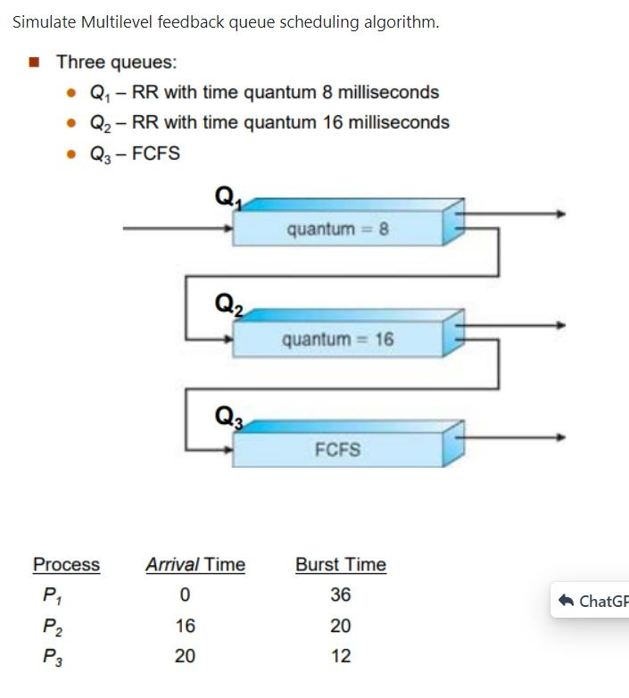

Ans.)

Code:

class Process:

def __init__(self, pid, arrival_time, burst_time):

self.pid = pid

self.arrival_time = arrival_time

self.burst_time = burst_time

self.remaining_time = burst_time

self.start_time = -1

self.completion_time = -1

def execute(self, quantum):

if self.remaining_time <= quantum:

time = self.remaining_time

self.remaining_time = 0

else:

time = quantum

self.remaining_time -= quantum

return time

def is_completed(self):

return self.remaining_time == 0

def turnaround_time(self):

return self.completion_time - self.arrival_time

def waiting_time(self):

return self.turnaround_time() - self.burst_time

def response_time(self):

return self.start_time - self.arrival_time

def relative_delay(self):

return self.waiting_time() / self.turnaround_time()

def multilevel_feedback_queue_scheduling(processes, quantum1=8, quantum2=16):

q1 = []

q2 = []

q3 = []

for process in processes:

q1.append(process)

current_time = 0

while q1 or q2 or q3:

if q1:

process = q1.pop(0)

process.start_time = current_time

time = process.execute(quantum1)

current_time += time

if process.is_completed():

process.completion_time = current_time

print(f"{process.pid}\t{process.turnaround_time()}\t{process.waiting_time()}\t{process.response_time()}\t{process.relative_delay()}")

else:

q2.append(process)

elif q2:

process = q2.pop(0)

process.start_time = current_time

time = process.execute(quantum2)

current_time += time

if process.is_completed():

process.completion_time = current_time

print(f"{process.pid}\t{process.turnaround_time()}\t{process.waiting_time()}\t{process.response_time()}\t{process.relative_delay()}")

else:

q3.append(process)

elif q3:

process = q3.pop(0)

process.start_time = current_time

time = process.burst_time

current_time += time

process.completion_time = current_time

print(f"{process.pid}\t{process.turnaround_time()}\t{process.waiting_time()}\t{process.response_time()}\t{process.relative_delay()}")

# Input

processes = [

Process("P1", 0, 36),

Process("P2", 16, 20),

Process("P3", 20, 12),

]

# Output: TAT, WT, RT, RD.

print("Process\tTAT\tWT\tRT\tRD")

multilevel_feedback_queue_scheduling(processes)

Output:

